Answer 6
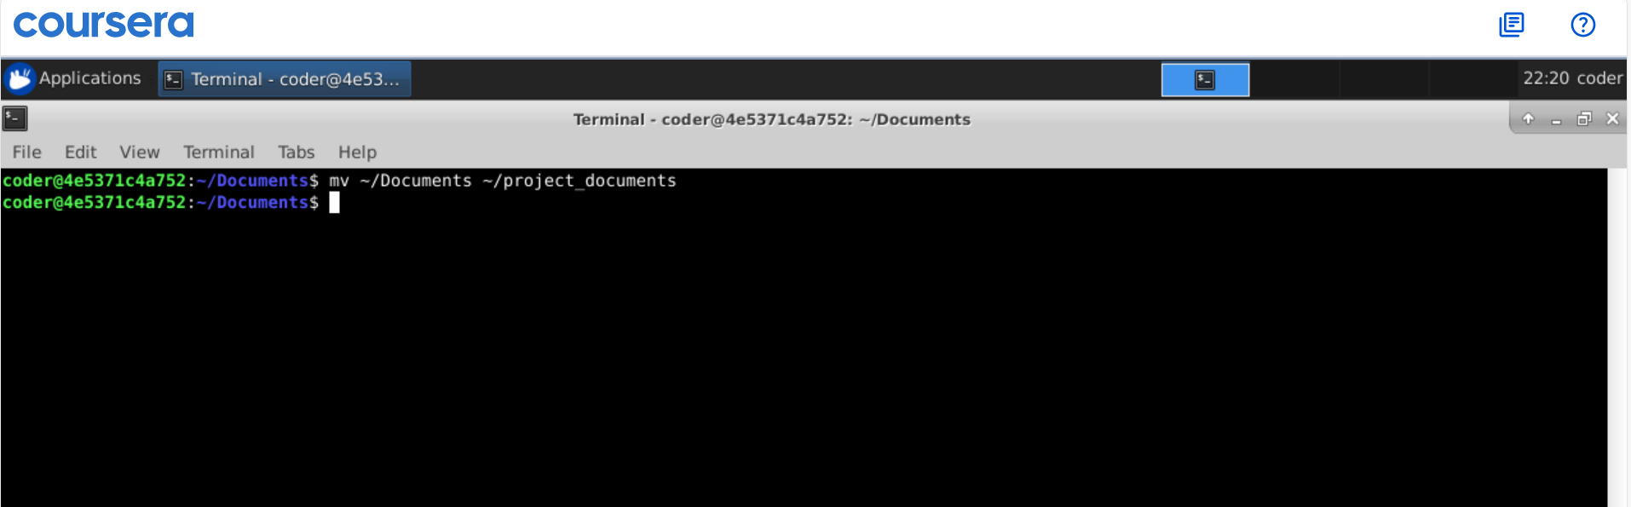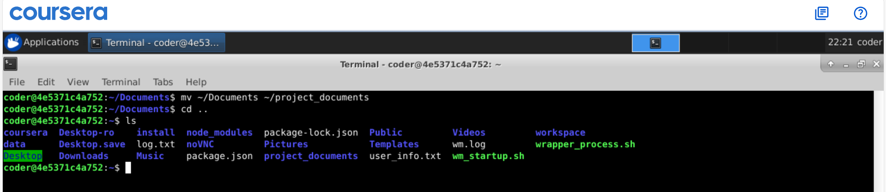
Explanation: we can use mv command to move file but at the same time we can use this command to rename a file without changing its content.

